**TECHNICAL REPORT**

**TEAM 11 (VEPH/20B)**

**ANALYTICAL REPORT ON GLOBAL SUICIDE RATE (2010-2020)**

**Content**

Introduction

Story of Data

Data Splitting and Preprocessing

Pre-Analysis

In-Analysis

Post-Analysis

Visualizations…………………………………………………………………………………….

Conclusion

# **Introduction**

Suicide remains one of the most pressing global public health challenges, ranking as a leading cause of death across multiple age groups. Each statistic represents not just a lost life, but a complex web of emotional, social, economic, and cultural factors that often go unaddressed. From young adolescents grappling with identity to adults burdened by financial and psychological stress, the causes of suicide are as varied as they are preventable.

In recent years, growing attention has been directed toward understanding the underlying risk patterns of suicide. However, despite increasing awareness, stigma and lack of access to effective mental health services continue to hinder progress. This reality demands a more data-driven, empathetic approach to suicide prevention, one that accounts for the lived experiences of vulnerable populations and tailors interventions accordingly.

## **Problem Statement**

This analysis seeks to examine global suicide trends with a focus on age, gender, and country-specific patterns. By identifying high-risk demographics and correlating suicide rates with contributing factors such as economic hardship, psychological conditions, chronic pain, and social isolation, the project aims to uncover actionable insights. Subtopics explored include demographic profiles and common triggers, the impact of stigma and mental health service accessibility, and the influence of socioeconomic and cultural dynamics.

Through this multidimensional lens, the project ultimately aspires to support targeted interventions and policymaking that can reduce suicide rates and strengthen global mental health systems.

## **Key Datasets and Methodologies**

The dataset consists of suicide data gathered between 2010 and 2020, covering victim’s country, the country’s GDP, number of suicide case registered, causes of suicide, triggers, and age and gender distribution. Microsoft Excel will be used for data processing, leveraging tools such as pivot tables for summarization, charts for visualization, and statistical functions for trend analysis.

# **Story of Data**

## **Data Source**

The dataset is sourced from Kaggle and supported with information from other sites, a well-known platform for public datasets and data science projects. The data focuses on the suicide rate and their causes in different countries. The data also speculate some age range, generation and the gender that were affected.

## **Data Collection Process**

This analysis began not with numbers, but with a need to understand the deeper realities of suicide. Instead of jumping into datasets found in the kaggle repository only, we explored reports from global health bodies like WHO, UNICEF, and mental health organizations to grasp the human, cultural, and economic dimensions of suicide.

We focused on data that reflected real-world complexity, linking mental health struggles to poverty, stigma, war, and social isolation. This deliberate approach ensured our findings weren’t just statistical, but grounded in lived experiences, with the goal of turning insights into meaningful public health action.

## **Data Structure**

The data is organized in an Excel table format with rows and columns representing individual transactions and relevant details. Some key columns in the dataset include:

1. **Country**: The name of the country where the suicide cases were recorded.
2. **Year**: The year in which the suicide data was collected or reported.
3. **Gender**: The sex of the individuals (Male or Female) involved in the suicide data.
4. **Age**: The age group category of the individuals (e.g., 5–14 years, 15–24 years, etc.).
5. **Suicide no**: The total number of suicides recorded for that demographic group.
6. **Population**: The total population of the demographic group (same age, gender, and country).
7. **Suicide by 100k pop**: Suicide rate per 100,000 individuals in the specific population group.
8. **HDI for year**: Human Development Index score for the country in that specific year.
9. **GDP per year**: The Gross Domestic Product of the country for that year (total economic output).
10. **GDP per Capita**: The GDP divided by the population, a measure of the average income per person.
11. **Generation**: The generational cohort of the individuals (e.g., Generation X, Millennials, etc.).
12. **Triggers**: Immediate or situational factors that may have precipitated the suicide (e.g., substance abuse, trauma).
13. **Causes**: Underlying causes or contributing risk factors (e.g., mental disorders, financial stress, chronic illness).

## **Important Features and Their Significance**

1. **Country:** plays a pivotal role in understanding geographic disparities. Suicide rates can vary significantly from one nation to another due to differences in culture, mental health infrastructure, social support systems, and stigma. Identifying high-risk countries helps in tailoring region-specific mental health policies and preventive programs.
2. **Age:** is another essential feature that reveals which life stages are most vulnerable to suicide. Adolescents, young adults, middle-aged individuals, and the elderly each face different psychological and socio-economic pressures, making it vital to develop age-appropriate mental health services.
3. **Suicide no**: provides a raw count that shows the scale of the issue within each demographic group. While useful, this metric must be analyzed alongside the **population** to derive the **suicide rate per 100,000 people**, which offers a standardized measure for meaningful comparisons across regions and age groups of varying sizes.
4. **GDP per year** and **GDP per capita** serve as indicators of national and individual economic conditions. These features help uncover whether economic prosperity correlates with better mental health or if economic disparities contribute to suicide risk. In many cases, economic wealth alone has not proven to be a protective factor, indicating that other societal elements must be considered.
5. **Triggers** and **causes** of suicide: offer the most direct insights into the underlying factors contributing to suicidal behavior. Understanding these elements is vital for designing prevention strategies that are both responsive and impactful.

**DATA LIMITATIONS OR BIASES**

1. Data formatting issues: less problem was encountered on this phase as the data formatting was simplified using different functions to minimize the errors on the dataset
2. Missing or Incomplete data: the incompleteness of this data can be regarded in the sense that extra columns containing the causes and triggers were added to make some sense of completion.
3. External factors experienced with this data is in the case of applying the functions to make the columns of causes and triggers aligned.

# **Data Splitting and Preprocessing**

**DATA CLEANING**

To maintain the relevance and reliability of the findings, the data was filtered to include only records from 2010 to 2020. This decision was based on:

* Recentness of social dynamics
* Consistency in global data reporting
* Modern relevance for public policy and intervention

Logical Association Using IF Function

Using spreadsheet logic (implemented in Excel or equivalent), an IF function was created to ensure that causes and triggers matched contextually. For example:

***=IF(AND(Cause="***Economic***", Trigger="job loss"), "*** Psychological***", "Other")***

This approach allowed categorization into composite conditions such as:

* Psychological
* Sociocultural
* Economic
* Access-related
* Environmental

*This logical synthesis helped in deriving more nuanced analytical layers for the final analysis*

**HANDLING MISSING VALUES**

Two new columns were introduced:

1. **Causes:** Refers to underlying psychological or socio-economic conditions that may predispose individuals to suicide. Examples include depression, unemployment, trauma, terminal illness.
2. **Triggers:** Refers to immediate events or stressors that may prompt suicidal actions. Examples include relationship breakup, job loss, public shame, academic failure.

*These columns were populated using a combination of domain knowledge, literature review, and correlational heuristics. They were matched against demographic and geographic trends observed in the data.*

## **Data Splitting**

The dataset was divided into Independent and Dependent variables.

**Category One: Independent Values**

* Generation
* Country
* Causes
* Triggers
* Gender

**Category Two: Dependent Values**

* Suicide Number
* Year
* Age
* Population
* Suicide/100k pop
* Country Year
* HDI for Year
* GDP for Year

## **Industry Context**

The analysis belongs to the Public and mental health statistical report covering the analysis of suicide rate globally; suicide prevention is a critical public health issue affecting populations globally.

## **Stakeholders**

* Government & Policymakers
* Healthcare & Mental Health Professionals
* NGOs & Advocacy Groups
* International Organizations  
  .

## **Value to the Industry**

* **Identifies High-Risk Groups**: Helps pinpoint age, gender, and regional demographics most vulnerable to suicide for targeted intervention.
* **Reveals Root Causes:** Highlights key triggers like mental illness, financial stress, and substance abuse, aiding in focused prevention efforts.
* **Informs Policy and Planning**: Supports data-driven decisions in designing effective mental health and suicide prevention programs.
* **Strengthens Mental Health Services:** Guides improvements in access, quality, and allocation of mental health resources.
* **Tracks Trends and Impact:** Enables continuous monitoring of suicide patterns and evaluation of existing public health interventions.
* **Promotes Awareness and Reduces Stigma:** Facilitates public education and open conversations about mental health, leading to broader societal support.

# **Pre-Analysis**

## **Potential Analysis**

1. Which age group is most likely to commit suicide in various nations?
2. Does the prevalence of suicide differ by nation or year, and are men or women more affected?
3. What are the differences in suicide rates between generational groups, such as Millennials and Baby Boomers?
4. Which countries have the highest and lowest rates of suicide?
5. Has the suicide rate in specific countries gone up or down over time?
6. What connection exists between suicide rates and the Human Development Index (HDI)?
7. Which suicide causes and triggers are most frequently mentioned?
8. Are some age or gender groups more impacted by particular triggers than others?
9. Do increases in suicide occur in conjunction with economic downturns (low GDP or HDI years)?
10. Does the suicide rate have a relationship with GDP per capita?

## **Potential Insights**

1. Males in their middle years may have higher suicide rates, especially in developed nations where economic stress is prevalent.
2. Suicide rates may be lower in nations with lower HDI, but these nations may also have less robust data collection or mental health support networks.
3. According to generational patterns, younger generations are more impacted by social and digital pressure, whereas older generations may have higher suicide rates as a result of loneliness.
4. Unemployment, broken relationships, or mental illness are examples of common causes that may differ by age or location.
5. Economic expansion may result in lower suicide rates, indicating a link between mental health and financial security.

# **In-Analysis**

## **Key Metrics**

1. The age group 35-54years top the charts with (636062) suicide rate, followed closely by age group 55-74years((471750), then age group 25-34years with (301939).
2. United States has the highest suicide-no of (246567),followed by Russian federation with sum of suicide of (206778), Japan is the third country with suicide rate
3. The Generation-x top the chart with 30%, followed by Boomer 20%, silent 19%, millennials 15%, and G.I Generation 10%
4. Year 2010 has the highest suicide-no of 238325, and there is a decline till 2020, thats the number or rate of suicide drop.
5. Republic of Korea,United state, USA, ChinaHong, Japan, and Germany are the 6 countries with the highest GDP.
6. Psychological causes have the highest HDI of 2234.251276.
7. Country with highest suicide/100kpop against sum of GDP per capita, Republic of korea, slovakia, lithuania, hungary, suriname, kazakhstan and Russian Federation are the best 7 countries with highest GDP per Capita.
8. Psychological has the highest number or rate of suicide of 567376, with trigger mental disorder 277214, and substance abuse 290162

## **In-Analysis Insights**

1. Identifying the Age Group with highest suicide rate will help the country direct their mental health resources towards the most risk demograhics.
2. United states , Russian, Japan, Republic of korea, Germany, Brazil, and USA has the highest suicide numbers, but Republic of korea, slovakia, Lithuainia, Hungary,suriname, kazakhstan and Russian federation has the highest rate per 100,000, this means the country should target mental health initiatives for countries with high rates.
3. Understanding or Analyzing the generational unit that is most at risk , helps the stakeholder/ country to know the generation thats most vulnerable , Generation-X shows the highest number of suicides , and this may be as a result of mid-life stress like financial stress, loss of job, failed relationship etc.
4. The analysis of causes/triggers against HDI(HUMAN DEVELOPMENT INDEX), helps to discover how development like education, income, relate to causes of suicide, countries with low HDI show more suicides related to economic hardship, while countries with high HDI show causes like depression, streess etc. the stakeholder should tailor prevention campaigns to specific socio-econmic challenges
5. Global suicide numbers was high in year 2010,with a sharp drop in 2016 and declined till 2020, this might be as a result of increased awareness, the government should create more awareness, create more social programs that will help to educate people about suicide and how to prevent it
6. For the Country with Highest GDP, United states, Republic of korea,united state, USA, ChinaHong, Japan, and Germany are the best 6 country with highest GDP and despite having highest GDP, The countries has not seen a significant drop in suicide rates, this suggest or implies that economic wealth alone isnt a protective or preventive factor for suicides.
7. The Top Contributing Causes/Triggers by Suicide Numbers, mental disorder, substance abuse, financial stress , chronic pain top the chart, the government should channel more resources to the health sector , and also provides more job opportunities to help reduce the suicide rate
8. The analysis of causes against GDP per Year will help us understand how economic changes affect causes of suicide numbers , for example, suicides due to loss of job or depression might happened due to the country facing economic recessions, the government should ensure to link economic policy to mental health support programs to help reduce the suicide rate in the country.

# **Post-Analysis**

## **Key Findings**

Analytical Report of Global Suicide Rate (2010–2020).

**Countries:**

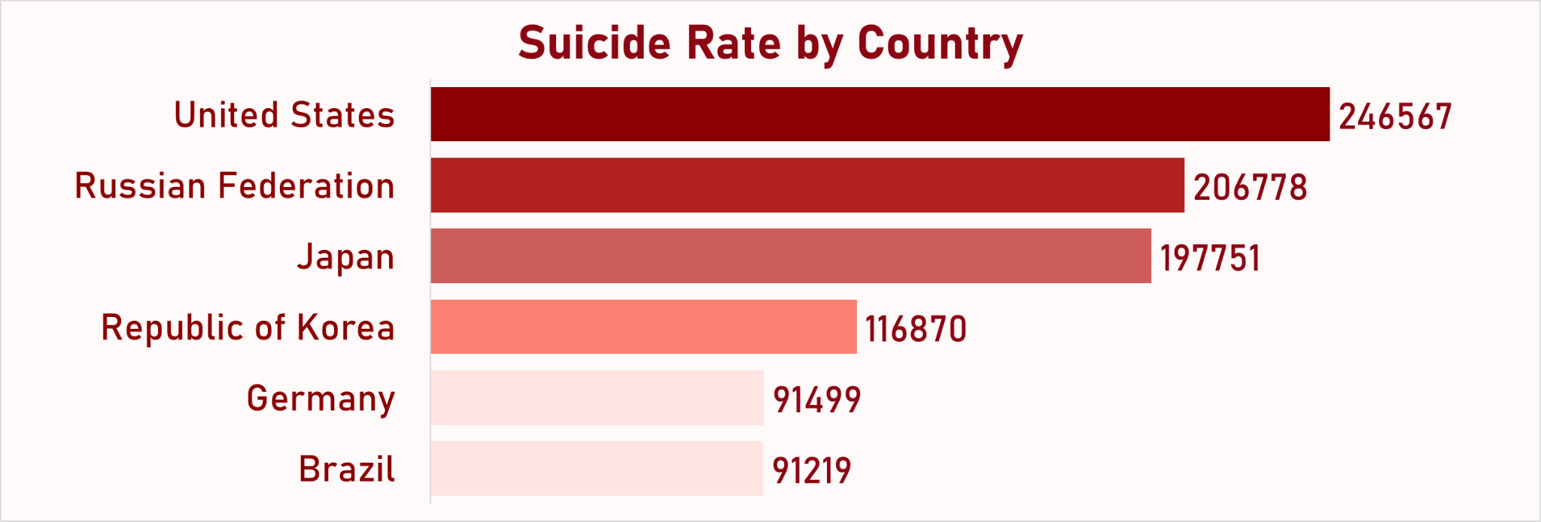

The deepest shade of the color from the map shows the highest numbers of recorded cases.

1. The United States is among the most affected, with 246,567 suicides cases reported from the year 2010 -2020, folowed by Russia Federation with 206,778, while japan recorded 197,751, South Korea Recorded 116,870, followed by Germany with 91,499 and finally Brazil recorded 91,219 cases.
2. Upon checking the trend for the highest suicide Contries, There is a gradual decline of suicide cases from 2010 - 2020.
3. United States which has the highest number of suicide cases recorded 77.95% for male cases while 22.05% of cases was recorded for female during the year 2010 -2020. This results shows that the males generally recorded the highest number of suicide cases for the year 2010 -2020.
4. Highest suicide rates for the most affected countries are inbetween 35–54 age group, followed by 55–74 years for all countries with highest cases of suicide cases.
5. The Generation X top the chart for the most affected countries followed by the Boomers
6. The top contributing factors are for countries with highest suicide cases are; Psychological factors, Health followed by Economical.

**Causes of suicide:**

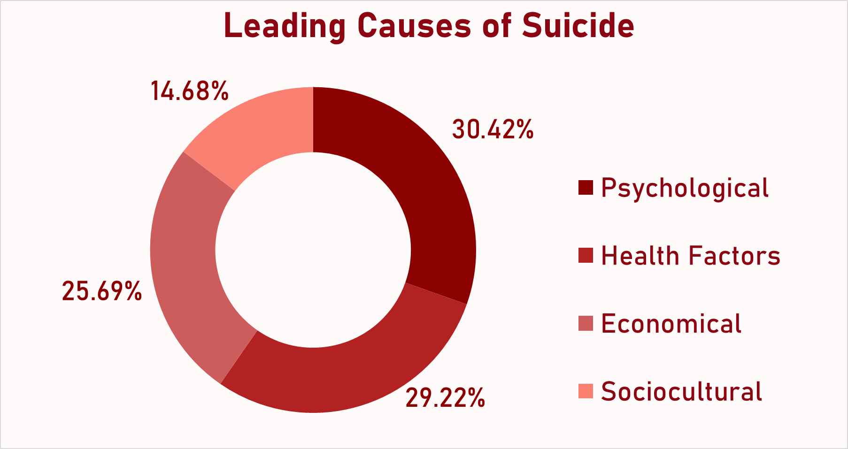

1. Economical

The total of 479,115 suicide were caused by economic problem. The number registered in 2016 dropped drastically to about 2,528 from 56,371 registered in 2015. However, this number rose immediately to 37,941 in 2017, followed by a gradual decrease and 8,235 was registered in 2020. (55-74) and (35-54) are the age brackets of suicide victims that were most caused by economic related issues. 74.78% of these victims were males while 25.22% were females. Also, United States (89429), Russian Federation (68074), and Japan (58084) are the top 3 countries affected.

1. Health Factors:

The total of 545,062 suicide were caused by health issue. The number registered in 2016 dropped drastically to about 3,644 from 50,971 registered in 2015. However, this is followed by a sharp increase of 54,423 in 2017, remained within this range until 2020 when the number dropped to 14,759. (35-54) and (55-74) are the age brackets of suicide victims that were most caused by health related issues. 76.54% of these victims were males while 23.46%were females. Also, Japan (72,250), United States (54,230), and Russian Federation (47,814) are the top 3 countries affected.

1. Psychological:

The total of 567,376 suicide were caused by psychological problem. The number registered in 2016 dropped drastically to about 8,780 from 74,502 registered in 2015. However, this number rose immediately to 39,017 in 2017, a slight increase till 2019 and a drop of 19,151 was registered in 2020. (35-54) and (55-74) are the age brackets of suicide victims that were most caused by psychological related issues. 75.82% of these victims were males while 24.18% were females. Also, United States (74,343), Russian Federation (62,592), and Germany (41,581) are the top 3 countries affected.

1. Sociocultural:

The total of 273,745 suicide were caused by sociocultural problem. the number registered in 2016 dropped drastically to about 651 from 21,267 registered in 2015. However, this number rose immediately to 31,934 in 2018, followed by a gradual decrease and 6,184 was registered in 2020. (35-54) and (55-74) are the age brackets of suicide victims that were most caused by sociocultural related issues. 72.69% of this victims were males while 27.31% were females. Also, Japan (39,003), United States (28,565), and Russian Federation (28,298) are the top 3 countries affected.

**Suicide trigger:**

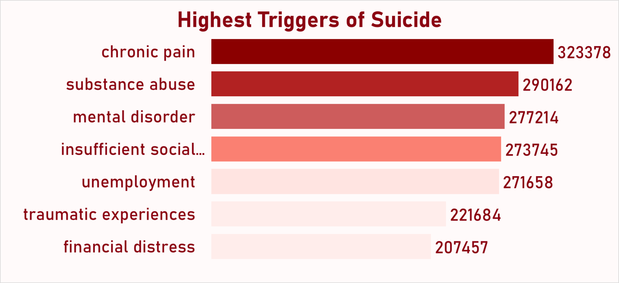

1. The major trigger is the psychological factor contributing about 63 billion globally between 2010 -2020. This might include mental health disorders such as depression, anxiety, and other psychological illnesses.
2. The Health Factor contributed about 50 billion globally which might include Chronic pains, terminal diseases, and substance abuse can contribute to suicide.
3. Economic Factors contributed 43 billion to suicide cases globally between the year 2010 -2020. This might be due to financial constrain , unemployment, poverty could lead to the causes of suicide.
4. Sociocultural Factors contributed about 34 billion to suicide cases globally. This might include social isolation, family breakdown, cultural stigma, discrimination in the society.

**Age:**

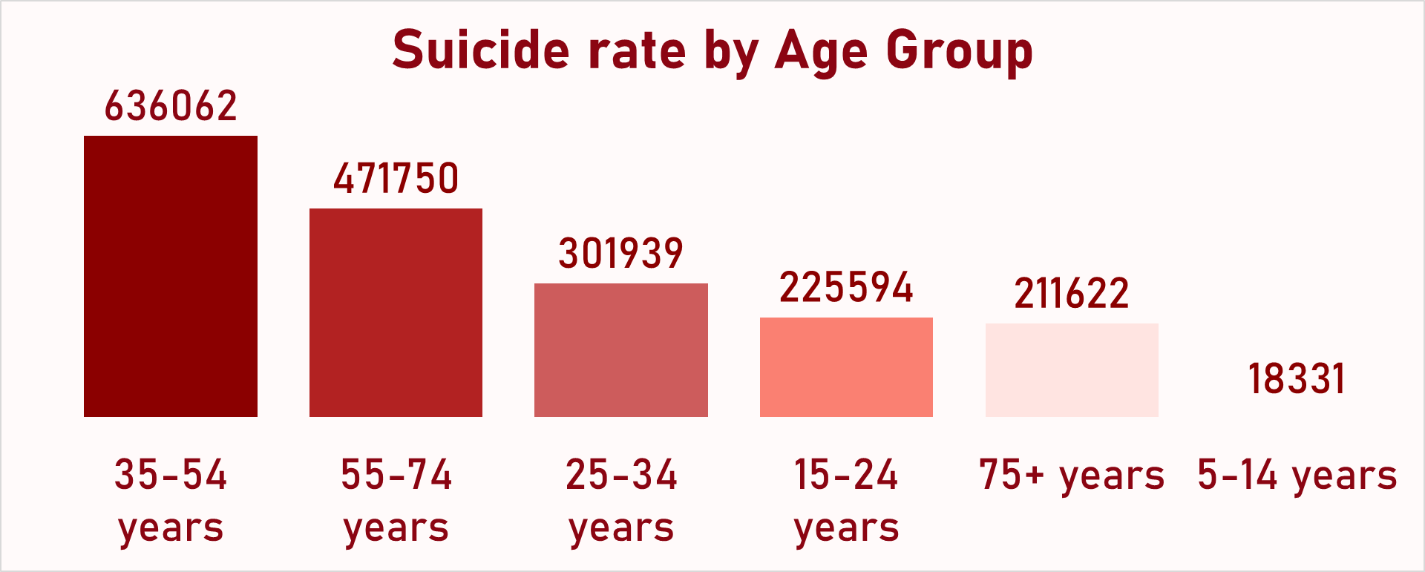

1. 5-14years:

A total of 18,331 individuals in the 5 to 14-year age group died by suicide. The numbers fluctuated over the years, peaking in 2018 with 2,243 cases and reaching their lowest in 2020 with 1,125 cases. Interestingly, despite 2015 being the year with the overall lowest suicide numbers, this group still recorded 1,681 cases in that year. The leading causes of suicide within this age range were economic, psychological, health-related, and sociocultural factors, in that order. Substance abuse emerged as the primary trigger. Males made up 60.09% of the victims, while females accounted for 39.91%. The most affected countries were the United States of America (2,274 cases), Mexico (2,179), and a second entry for the United States (2,108).

1. 15-24 years:

Among individuals aged 15 to 24, there were 225,594 reported suicide cases. The trend began with 27,665 cases in 2010 and experienced moderate rises and falls over the decade, except for sharp declines in 2016 (1,195 cases) and 2020 (7,365 cases). The most prevalent causes were health issues, psychological struggles, economic difficulties, and sociocultural pressures. Key triggers included lack of social support (39,435 cases), substance abuse (35,058), and traumatic experiences (34,235). Males represented a significant 75.06% of these suicides, while females made up 24.94%. The countries most impacted were the United States (29,744 cases), Russian Federation (26,551), and Mexico (17,797).

1. 25-34 years:

This age bracket saw a total of 301,939 suicides. The cases started at 38,258 in 2010, with relatively steady fluctuations over the years. Notably, there were steep declines in 2016 (2,070 cases) and 2020 (8,183 cases). Suicides in this group were predominantly driven by economic reasons, followed by psychological, health, and sociocultural issues. The main contributing factors were insufficient social support (57,998 cases), unemployment (55,873), and substance abuse (47,547). A large majority, 78.99%, were male victims, with females accounting for 21.01%. The top three affected countries were the Russian Federation (45,042), United States (37,917), and Japan (25,165).

1. 35-54 years:

This age group recorded the highest total of suicide cases, amounting to 636,062. The numbers began at 87,222 in 2010, showing a gradual decrease over the years, with particularly sharp drops in 2016 (5,766 cases) and 2020 (13,567 cases). Psychological issues were the leading cause of suicide in this group, followed by health problems, economic hardship, and sociocultural challenges. The most frequently reported triggers included chronic pain (136,707 cases), mental disorders (121,866), and substance abuse (99,869). Males made up 76.60% of these cases, while females accounted for 23.40%. The countries most affected were the United States (92,780 cases), Russian Federation (69,409), and Japan (60,927).

1. 55-74 years:

There were 471,750 suicide cases. The numbers started at 59,647 in 2010 and generally declined over the years, with dramatic reductions in 2016 (4,715 cases) and 2020 (11,231 cases). Economic factors were the primary cause of suicide in this group, followed by psychological, health-related, and sociocultural reasons. Common triggers included chronic pain (88,708 cases), unemployment (80,568), and substance abuse (68,199). Males accounted for 74.05% of these suicides, while 25.95% were female victims. The countries with the highest cases in this category were the United States (63,860), Japan (62,663), and the Russian Federation (42,470).

1. 75+:

A total of 211,622 suicide cases were reported among individuals aged 75 and above. The figures began at 23,773 in 2010 and showed modest fluctuations throughout the decade, with notable drops in 2016 (1,857 cases) and 2020 (6,858 cases). The leading causes were psychological challenges, followed by health issues, economic difficulties, and sociocultural pressures. The most significant triggers included traumatic experiences (36,680 cases), substance abuse (35,868), and lack of social support (33,087). In terms of gender distribution, 70.54% of the victims were male and 29.46% were female. The countries with the highest numbers were Japan (32,001 cases), Russian Federation (22,005), and Germany (21,040).

**Gender:**

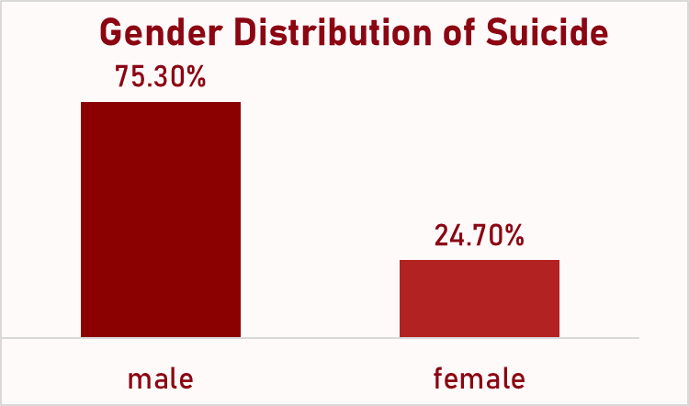

**Male**

1. Male at 75.30% ( ) had the highest suicide death and top at the worse hit gender by suicide death.
2. The annual suicide trends shows that male folks had the highest suicide death in the year 2010, 2011 and 2012 which accounted for 184144, 181475 and 176732 respectively
3. 2016 accounted for the lowest death of the male gender with a death rate of 12099
4. For the male folks there was a consistent drop in suicide death from 2010-2015 and a deep dip in 2016, however the rate increases again from 2017 to 2019 and a drop in 2020.
5. The trigger of suicide in this gender had chronic pain (256,201) as the highest followed by substance abuse (217,221), mental disorder (212,958), unemployment (200,303) and insufficient social support (198,992) while financial distress was the lowest trigger with 157,992.
6. Psychological (31%), health factors (30%), Economical (25%) and Sociocultural (14%) where the leading causes of suicide death among the male folks
7. The effect of generation on suicide mortality shows Generation X (34%), Boomers (20%), Millennials (19%), Silent (18%) and G.I. Generation (9%) for the male folks.
8. The three highest countries based on suicides death recorded in male folks were United States (192,197), Russia (166,297) and Japan (132,732)
9. Based on age group, the age bracket of 35-54years suffered most from male suicide death with a recorded mortality of (487,205), this was closely followed by 55-74 years (349,322) and 25-34year (288,512). The 5-14 years age bracket were the lowest male age group affected by suicide.

**Female**

1. The female gender recorded a total of 24.70% suicide mortality rate; this represents thrice the mortality recorded in the male folks.
2. The year 2011, 2010 and 2012 accounted for the worst years for the female folks as their suicide death rates were the highest for these years. The death rate was 54532, 54181 and 52920 respectively.
3. 2016 was the year with the lowest suicide death for this gender with 3504 deaths recorded.
4. Same as for the male folk, the annual suicide trends also showed a constant rise from 2010 to 2015 with a deep drop in 2016 and subsequent increase from 2017 to 2019. A final drop was seen in 2020.
5. The top rank age group by suicide death was 35-54 years and this also accounted for the highest suicide mortality for the female folks with 148,857 deaths.
6. The second and third positions by age classification were the 55-74 years and 25-34 years accounting for 122,428 and 63,427 respectively.
7. Age bracket 5-14 years had the less female suicide death rate of 7316.
8. Psychological (30%), Health factors (28%) and Economical (20%) top the causes of suicide death among the female folks while sociocultural causes were the lowest with 16% mortality rate.
9. The female gender has their highest suicide trigger as insufficient social support (74,753), substance abuse (72,933) and Unemployment (71,355). Just like in the male folks, financial distress (49,465) was the lowest trigger for this gender type.
10. Japan (65,019) and United States (54,370) were the countries with the leading numbers of female suicide death.
11. Female born in Generation X with a score of 30% accounted for the highest suicide death by generation. This was closely followed by Silent (22%), and Boomers (20%) generations. Millennials and G.I Generations with 15% and 13% were the lowest.

# **Recommendations**

# **Country**

# Provision or access to counseling and mental health facilities can help reduce the rate of suicide in the affected countries. Also awareness campaigns, especially targeting male between the ages of 35–54 age range can also help to reduce the suicide rate.

# The United Nations can help invest in nationwide mental health infrastructure and community-based support systems globally.

# Government should provide citizens with mental health benefits, especially targeting Gen X and Boomers or male which are most affected.

# Governments should legislate better access to mental healthcare, reduce economic hardship by engaging citizens between the ages of 34 -54 years with Government benefits.

# Countries with highest cases should introduce suicide prevention hotlines in case of suicide cases.

# **Causes**

# Strengthen social safety nets such as unemployment insurance, emergency housing, food support. Expand financial counseling and job retraining programs especially after economic downturns.

# Early warning systems tied to economic indicators (e.g., layoffs, inflation) to predict and intervene before spikes.

# Improve access to chronic illness support and pain management.

# Integrate mental health services into primary healthcare, especially for aging populations with chronic disease.

# Offer post-diagnosis counseling for life-threatening or degenerative illnesses.

# Massive scaling of mental health infrastructure such as affordable therapy, hotlines, mobile mental health apps. Combat stigma through national campaigns in schools, workplaces, and media.

# Early intervention programs in schools and workplaces for stress, depression, anxiety.

# Community engagement programs to reduce isolation, especially in immigrant and minority communities.

# Education and awareness programs addressing bullying, discrimination, and cultural dislocation.

# Promote inclusivity and social support networks via religious groups, NGOs, and civic organizations.

# Invest in data systems to monitor real-time suicide trends by cause. Create cause-specific suicide prevention task forces at national levels.

# Partner with tech and social media platforms to flag and support at-risk individuals using behavioral patterns.

# Since over 70% of victims were male in every category, create male-focused mental health campaigns. Also, encourage help-seeking behavior in men by using relatable role models, normalizing therapy, and reducing stigma.

# 

# **Triggers**

# Government should provide affordable mental health facilities for citizens to access mental health services. Mental health cases recorded by physicians should not be made public as this may cause those with mental issues from accessing these facilities because of publishing personal information to the general public.Training and screening for the physicians and citizens to detect mental health symptoms should be provided by the Government.

# Government should Integrate mental health services into primary healthcare centers and close to citizens for easy access.Provide counseling support for patients with chronic illnesses like kidney, cancer hillnesses.

# Economic Programs that help citizens financially and job recovery initiatives in high-risk areas like the United State and Russia Federation should be provided by the government to ease financial stress.

# Educate communities to avoid negative mental health conversations and encourage dialogues.

# 

# **Age bracket**

# Introduce age-appropriate emotional literacy and coping skills in school curricula. Help children recognize and express emotions safely. Equip parents and guardians with tools to identify early warning signs of distress and substance exposure. Parenting workshops and subsidized counseling can be crucial.

# Enforce stricter regulations and community monitoring in environments where children may be exposed to substance abuse. Offer after-school programs and safe recreational spaces that provide mentorship and psychological support to at-risk youth. Also, ensure every school has trained mental health professionals for early intervention.

# Create youth mentorship networks at schools, universities, and community centers to help build resilience and reduce isolation. Provide subsidized or free mental health services, particularly in educational institutions and underprivileged areas. Implement trauma recovery programs through schools and community organizations, especially for youth exposed to violence, abuse, or displacement.

# Launch targeted social media and community awareness campaigns to reduce stigma around mental health and promote help-seeking behavior.

# Ensure youth-oriented suicide prevention hotlines are widely promoted and easy to access 24/7.

# Introduce government-sponsored career development, upskilling, and job-placement services to reduce unemployment stress. Establish centers that focus specifically on the challenges of early adulthood, such as career pressure, relationships, and identity struggles. Utilize teletherapy and anonymous chat services tailored to tech-savvy young adults. Foster social integration through events, workshops, and group therapy to mitigate loneliness and build supportive networks.

# Alcohol and Drug Prevention Programs: Expand outreach on addiction awareness and prevention through relatable influencers and media.

1. Offer health facilities where physical and mental health professionals work together to treat comorbid conditions like chronic pain and depression. Encourage employers to support mental wellness by promoting flexible schedules, mental health leave, and stress-reduction workshops. Make access to addiction treatment and pain management programs more affordable and less stigmatized.

Since men dominate suicide rates in this group, introduce male-focused campaigns that normalize vulnerability and encourage emotional openness. Provide affordable counseling for couples and families to address mid-life crises, relationship breakdowns, and parenting stressors.

1. Establish support systems where individuals can openly discuss their health struggles and receive psychological reinforcement. Offer employment programs for individuals aged 55+ to reduce economic dependency and restore purpose. Increase availability of mental health professionals trained in aging-related psychological concerns. Encourage participation in local volunteerism, clubs, or religious groups to build a sense of belonging.

Tailor addiction treatment programs to older individuals, focusing on shame, isolation, and age-specific withdrawal needs.

1. Implement regular mental health assessments and companionship visits for elderly individuals living alone. Provide grief-specific therapy for those facing loss of loved ones, independence, or mobility. Offer transportation, recreational programs, and group therapy to minimize isolation and promote purpose.

Educate caregivers to detect depression, cognitive decline, and suicide warning signs in the elderly. Encourage faith-based or cultural support groups that offer comfort and belonging to the elderly population.

**Gender**

**Male**

1. Initiate health care system response to support the male folks, supports like introduction of chronic pain rehabilitation centers that include psychological therapy for the male folks.
2. Expand chronic pain management programs to integrate mental health support for men.
3. Promote the inclusion of male-friendly mental health services in workplaces and communities to foster men's health seeking behaviours.
4. Government should develop policies and collaborate with industries to help promote job retention programs especially for men aged 35-74 years.
5. Communities should play a part by improving engagement at that level through community -based initiation that are focused on combating isolation and fostering networking.
6. Implement mental health outreaches in workplaces, especially for the Generation Xers -the highest risk male generation.
7. Country -specifics action plans should be focused on improving collaboration with National health agencies to introduces male-focused suicide prevention framework.

# **Females**

# For generation X women (30% suicide rate), developing work-life balance programs, stress relief initiatives and psychological support in workplaces.

# For the silent and Boomers generations, implement elderly check-in programs and community inclusion efforts to reduce isolation

# Japan and U.S. should integrate suicide prevention interventions into their public health and social services programs and encourage women to participate.

# Employ support networks and mental health services for women to improve mental health resources, group therapy and peer-led support.

# Integrate routine mental health screening to services offered to women during annual checkup, routine hospital visits and women -centered health interventions.

# Integrate suicide prevention activities into the program for girl child to prevent future participation in suicide threats.

## 

## 

## 

## 

## 

## 

## 

## 

## 

## 

## 

## 

## **Visualization**

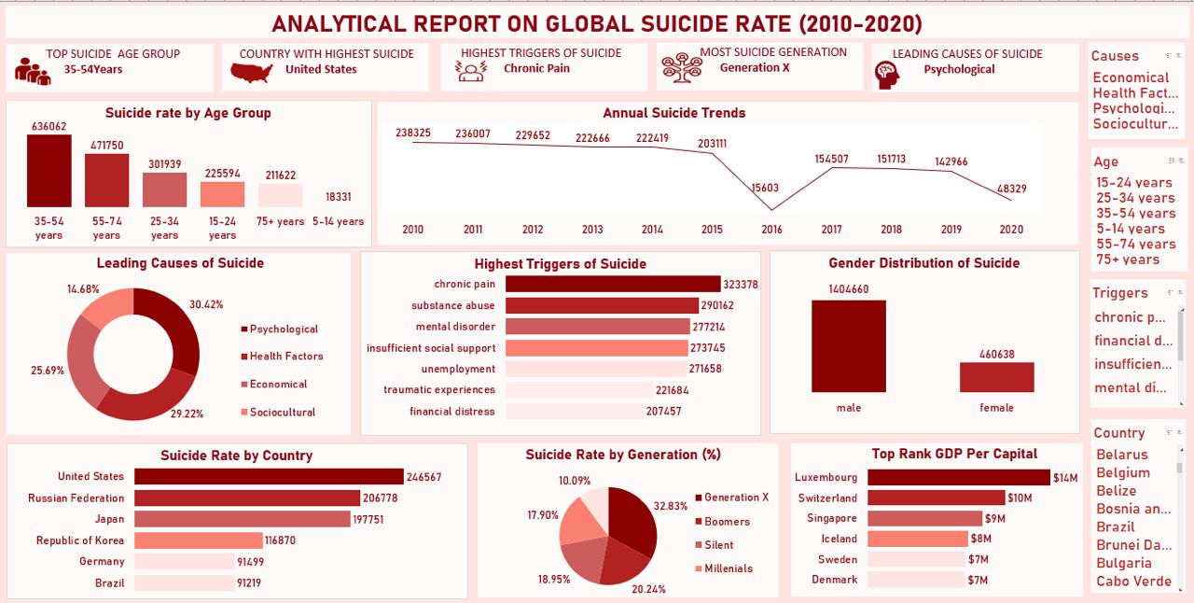

## **Excel Dashboard**

## 

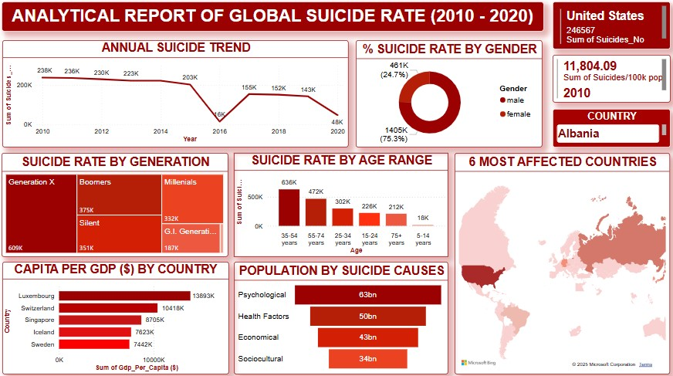

**Power BI dashboard**

**STEPS FOLLOWED TO VISUALIZE OUR ANALYSIS USING POWER BI**

1. We imported the already cleaned Dataset from the Excel get data source.
2. Once selected, we loaded the data into the Power BI workspace to begin analysis.
3. We created Title bar to represent our analysis
4. Explored different visualization charts like;

* Line charts (which was used to identify annual suicide trend over time)
* Pie chart (which was used to represent the percentage of suicide rate by gender)
* Tree map (Which was used to evaluate the suicide rate by generation impact)
* Column chart (Which was used to represent how suicide rate varies across different age group)
* Map chart (Which was used to display suicide rate across the globe)
* Bar Chart (Which was used to show Top Five Countries Gross Domestic Product – GDP) and
* Funnel Chart (Which was used to fine-tune the population of suicide causes around the globe for the period of time.)

1. We used the Q & A features in Power BI to refine our Insights on the Country with the highest suicide cases and the year with the peak suicide cases.
2. We added Slicer and Filter to make the report interactive, this slicer is based on key fields like the Country, which will allow for easy look-through on how different countries around the globe responded to suicide rates.
3. We Formatted the report by customizing the charts data labels, colors, titles, added outlines, visual borders, and rounded corners, to make our report visuals appealing and easy to understand.
4. We finally arranged the visuals in a way that told a clear, logical and analytical story.
5. Identified our Observations and communicated our Findings.

## 

# 

### **Conclusion**

The comprehensive analysis of global suicide data across age groups, causes, and countries reveals critical patterns that demand targeted intervention. Generation X (ages 35–54) consistently recorded the highest number of suicides, signaling a need for focused mental health and socio-economic support tailored to mid-life challenges such as job insecurity, chronic stress, and personal loss.

Although high-income nations like the United States, Japan, and Germany report the largest suicide counts, the highest suicide rates per capita are found in countries such as South Korea, Lithuania, and Kazakhstan, emphasizing that economic strength alone does not safeguard mental well-being. Additionally, the variation in suicide causes by Human Development Index (HDI) levels shows that economic hardship prevails in less developed nations, while psychological issues dominate in more advanced economies.

Despite a gradual global decline in suicide numbers from 2010 to 2020 which is likely influenced by increased awareness and mental health initiatives, the persistently high rates in many regions point to the need for sustained and adaptive strategies. Furthermore, the recurring triggers of suicide such as mental disorders, substance abuse, financial stress, and chronic pain highlight the urgent need for comprehensive public health, employment, and social support systems.

In conclusion, suicide prevention must be multifaceted: aligning economic policy with mental health support, tailoring interventions to the socio-economic realities of each region, and prioritizing vulnerable age groups and nations with high suicide rates. Only through targeted, data-informed strategies can nations reduce the burden of suicide and promote well-being across generations.

‌